**PRACTICAL: 4**

**AIM:**

Create a temperature converter Application. (Fahrenheit-Celsius) **.**

**THEORY:**

We have used Radio Buttons in this application to take one choice from user from the list of choices provided to the user. The use of Radio Button is to let user choose only one choice from the list. We then took input from the user using Edit Text and converted the Temperature to desired unit of Temperature.

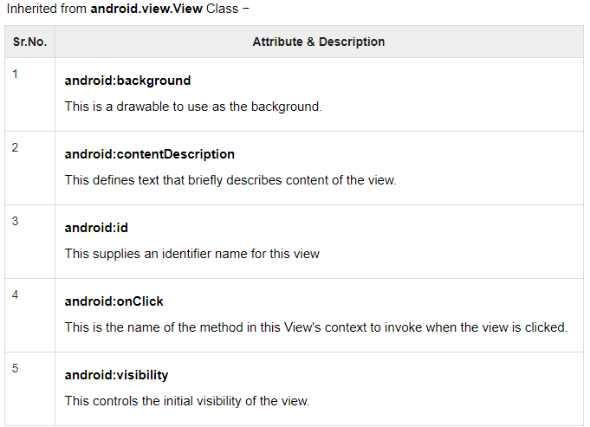

**CODE:**

|  |
| --- |
| **// MainActivity.java**  package com.example.temprature;  import androidx.appcompat.app.AppCompatActivity;  import android.os.Bundle;  import android.view.View;  import android.widget.Button;  import android.widget.EditText;  import android.widget.RadioButton;  public class MainActivity extends AppCompatActivity {  Button btn_cf, btn_fc, btn_ck, btn_fk, btn_kf, btn_kc;  EditText et_f, et_c, et_k;  RadioButton rb_c, rb_f, rb_k;  @Override  protected void onCreate(Bundle savedInstanceState) {  super.onCreate(savedInstanceState);  setContentView(R.layout.activity_main);  btn_cf = findViewById(R.id.btn_cf);  btn_ck = findViewById(R.id.btn_ck);  btn_fc = findViewById(R.id.btn_fc);  btn_fk = findViewById(R.id.btn_fk);  btn_kf = findViewById(R.id.btn_kf);  btn_kc = findViewById(R.id.btn_kc);  et_f = findViewById(R.id.et_f);  et_c = findViewById(R.id.et_c);  et_k=findViewById(R.id.et_k);  rb_c = findViewById(R.id.rb_c);  rb_f = findViewById(R.id.rb_f);  rb_k = findViewById(R.id.rb_k);  btn_cf.setOnClickListener(new View.OnClickListener() {  @Override  public void onClick(View v) {  float c = Float.parseFloat(et_c.getText().toString());  float f = (c*(float) 9/5)+32;  et_f.setText(""+f);  }  });  btn_ck.setOnClickListener(new View.OnClickListener() {  @Override  public void onClick(View v) {  float c= Float.parseFloat(et_c.getText().toString());  float k = c+ (float) 273.15;  et_k.setText(""+k);  }  });  btn_fc.setOnClickListener(new View.OnClickListener() {  @Override  public void onClick(View v) {  float f = Float.parseFloat(et_f.getText().toString());  float c = (f-32)*((float)5/9);  et_c.setText(""+c);  }  });  btn_fk.setOnClickListener(new View.OnClickListener() {  @Override  public void onClick(View v) {  float f = Float.parseFloat(et_f.getText().toString());  float k = (f-32)*((float)5/9)+ (float)273.15;  et_k.setText(""+k);  }  });  btn_kf.setOnClickListener(new View.OnClickListener() {  @Override  public void onClick(View v) {  float k = Float.parseFloat(et_k.getText().toString());  float f = (k-(float)273.15)*((float)9/5)+32;  et_f.setText(""+f);  }  });  btn_kc.setOnClickListener(new View.OnClickListener() {  @Override  public void onClick(View v) {  float k = Float.parseFloat(et_k.getText().toString());  float c = k-(float)273.15;  et_c.setText(""+c);  }  });  }  }  **// AndroidManifest.xml**  <?xml version="1.0" encoding="utf-8"?>  <manifest xmlns:android="http://schemas.android.com/apk/res/android"  package="com.example.temprature">  <application  android:allowBackup="true"  android:icon="@mipmap/ic_launcher"  android:label="@string/app_name"  android:roundIcon="@mipmap/ic_launcher_round"  android:supportsRtl="true"  android:theme="@style/AppTheme">  <activity android:name=".MainActivity">  <intent-filter>  <action android:name="android.intent.action.MAIN" />  <category android:name="android.intent.category.LAUNCHER" />  </intent-filter>  </activity>  </application>  </manifest>  **// activity_main.xml**  <?xml version="1.0" encoding="utf-8"?>  <androidx.constraintlayout.widget.ConstraintLayout xmlns:android="http://schemas.android.com/apk/res/android"  xmlns:app="http://schemas.android.com/apk/res-auto"  xmlns:tools="http://schemas.android.com/tools"  android:layout_width="match_parent"  android:layout_height="match_parent"  tools:context=".MainActivity">  <EditText  android:id="@+id/et_f"  android:layout_width="266dp"  android:layout_height="46dp"  android:layout_marginStart="52dp"  android:layout_marginTop="260dp"  android:ems="10"  android:inputType="numberDecimal"  android:textColor="@color/colorPrimary"  app:layout_constraintStart_toStartOf="parent"  app:layout_constraintTop_toTopOf="parent" />  <EditText  android:id="@+id/et_c"  android:layout_width="266dp"  android:layout_height="46dp"  android:layout_marginStart="52dp"  android:layout_marginTop="100dp"  android:ems="10"  android:inputType="numberDecimal"  android:scrollbarThumbHorizontal="@color/colorPrimary"  android:scrollbarThumbVertical="@color/colorPrimary"  android:scrollbarTrackHorizontal="@color/colorPrimary"  android:scrollbarTrackVertical="@color/colorPrimary"  android:textColor="@color/colorPrimary"  android:textColorHighlight="@color/colorPrimary"  android:textColorHint="@color/colorPrimary"  android:textColorLink="@color/colorPrimary"  android:textCursorDrawable="@color/colorPrimary"  app:layout_constraintStart_toStartOf="parent"  app:layout_constraintTop_toTopOf="parent" />  <EditText  android:id="@+id/et_k"  android:layout_width="266dp"  android:layout_height="46dp"  android:layout_marginStart="52dp"  android:layout_marginTop="420dp"  android:ems="10"  android:inputType="numberDecimal"  android:textColor="@color/colorPrimary"  app:layout_constraintStart_toStartOf="parent"  app:layout_constraintTop_toTopOf="parent" />  <TextView  android:id="@+id/textView2"  android:layout_width="wrap_content"  android:layout_height="wrap_content"  android:layout_marginStart="328dp"  android:layout_marginTop="100dp"  android:text="C"  android:textColor="@color/colorPrimary"  android:textSize="30sp"  app:layout_constraintStart_toStartOf="parent"  app:layout_constraintTop_toTopOf="parent" />  <TextView  android:id="@+id/textView3"  android:layout_width="wrap_content"  android:layout_height="wrap_content"  android:layout_marginStart="328dp"  android:layout_marginTop="260dp"  android:text="F"  android:textColor="@color/colorPrimary"  android:textSize="30sp"  app:layout_constraintStart_toStartOf="parent"  app:layout_constraintTop_toTopOf="parent" />  <TextView  android:id="@+id/textView4"  android:layout_width="wrap_content"  android:layout_height="wrap_content"  android:layout_marginStart="328dp"  android:layout_marginTop="420dp"  android:text="K"  android:textColor="@color/colorPrimary"  android:textSize="30sp"  app:layout_constraintStart_toStartOf="parent"  app:layout_constraintTop_toTopOf="parent" />  <Button  android:id="@+id/btn_cf"  android:layout_width="wrap_content"  android:layout_height="wrap_content"  android:layout_marginStart="72dp"  android:layout_marginTop="164dp"  android:background="@color/colorPrimary"  android:text="to F"  android:textColor="@android:color/background_light"  android:textSize="24sp"  app:layout_constraintStart_toStartOf="parent"  app:layout_constraintTop_toTopOf="parent" />  <Button  android:id="@+id/btn_kf"  android:layout_width="wrap_content"  android:layout_height="wrap_content"  android:layout_marginStart="72dp"  android:layout_marginTop="496dp"  android:background="@color/colorPrimary"  android:text="to F"  android:textColor="@android:color/background_light"  android:textSize="24sp"  app:layout_constraintStart_toStartOf="parent"  app:layout_constraintTop_toTopOf="parent" />  <Button  android:id="@+id/btn_ck"  android:layout_width="wrap_content"  android:layout_height="wrap_content"  android:layout_marginStart="204dp"  android:layout_marginTop="164dp"  android:background="@color/colorPrimary"  android:text="to K"  android:textColor="@android:color/background_light"  android:textSize="24sp"  app:layout_constraintStart_toStartOf="parent"  app:layout_constraintTop_toTopOf="parent" />  <Button  android:id="@+id/btn_fc"  android:layout_width="wrap_content"  android:layout_height="wrap_content"  android:layout_marginStart="204dp"  android:layout_marginTop="336dp"  android:background="@color/colorPrimary"  android:text="to C"  android:textColor="@android:color/background_light"  android:textSize="24sp"  app:layout_constraintStart_toStartOf="parent"  app:layout_constraintTop_toTopOf="parent" />  <Button  android:id="@+id/btn_kc"  android:layout_width="wrap_content"  android:layout_height="wrap_content"  android:layout_marginStart="204dp"  android:layout_marginTop="496dp"  android:background="@color/colorPrimary"  android:text="to C"  android:textColor="@android:color/background_light"  android:textSize="24sp"  app:layout_constraintStart_toStartOf="parent"  app:layout_constraintTop_toTopOf="parent" />  <Button  android:id="@+id/btn_fk"  android:layout_width="wrap_content"  android:layout_height="wrap_content"  android:layout_marginStart="72dp"  android:layout_marginTop="336dp"  android:background="@color/colorPrimary"  android:text="to K"  android:textColor="@android:color/background_light"  android:textSize="24sp"  app:layout_constraintStart_toStartOf="parent"  app:layout_constraintTop_toTopOf="parent" />  <RadioGroup  android:id="@+id/rg_1"  android:layout_width="213dp"  android:layout_height="723dp"  app:layout_constraintStart_toStartOf="parent"  app:layout_constraintTop_toTopOf="parent">  <RadioButton  android:id="@+id/rb_c"  android:layout_width="wrap_content"  android:layout_height="wrap_content"  android:layout_marginStart="20dp"  android:layout_marginTop="100dp"  android:scrollbarTrackHorizontal="@color/colorPrimary"  android:scrollbarTrackVertical="@color/colorPrimary"  android:textColor="@color/colorPrimary"  android:textColorHighlight="@color/colorPrimary"  android:textColorHint="@color/colorPrimary"  android:textColorLink="@color/colorPrimary"  android:textCursorDrawable="@color/colorPrimary"  app:layout_constraintStart_toStartOf="parent"  app:layout_constraintTop_toTopOf="parent" />  <RadioButton  android:id="@+id/rb_f"  android:layout_width="wrap_content"  android:layout_height="wrap_content"  android:layout_marginStart="20dp"  android:layout_marginTop="130dp"  android:scrollbarTrackHorizontal="@color/colorPrimary"  android:scrollbarTrackVertical="@color/colorPrimary"  android:textColor="@color/colorPrimary"  android:textColorHighlight="@color/colorPrimary"  android:textColorHint="@color/colorPrimary"  android:textColorLink="@color/colorPrimary"  android:textCursorDrawable="@color/colorPrimary"  app:layout_constraintStart_toStartOf="parent"  app:layout_constraintTop_toTopOf="parent" />  <RadioButton  android:id="@+id/rb_k"  android:layout_width="wrap_content"  android:layout_height="wrap_content"  android:layout_marginStart="20dp"  android:layout_marginTop="127dp"  android:scrollbarTrackHorizontal="@color/colorPrimary"  android:scrollbarTrackVertical="@color/colorPrimary"  android:textColor="@color/colorPrimary"  android:textColorHighlight="@color/colorPrimary"  android:textColorHint="@color/colorPrimary"  android:textColorLink="@color/colorPrimary"  android:textCursorDrawable="@color/colorPrimary"  app:layout_constraintStart_toStartOf="parent"  app:layout_constraintTop_toTopOf="parent" />  </RadioGroup>  </androidx.constraintlayout.widget.ConstraintLayout> |

**OUTPUT:**

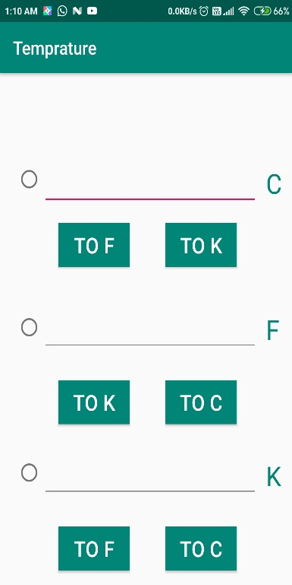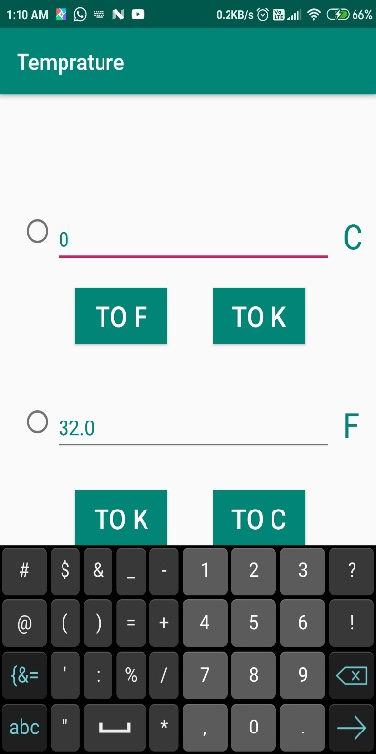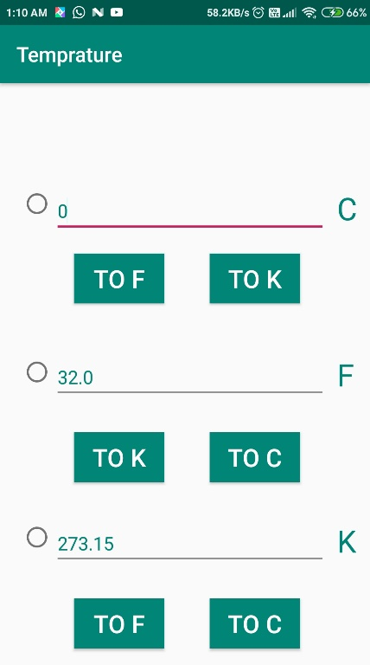

**LATEST APPLICATIONS:**

Thermometer++, Fever Tracker, EasyBBQ, Thermometer, Real Thermometer etc.

**LEARNING OUTCOME:**

1. We learnt how to work with Radio button in an application.
2. We also learnt how to take temperature input only in numeric form (when you tried to enter it won’t accept the alphabets.) from user and convert it into desired unit using Radio buttons. And finally displayed the output in TextField.